Paylocity Benefits Dashboard

Tester Name : Arda Sungu

Testing ground : USER INTERFACE IN GOOGLE AND FIREFOX SEARCH ENGINES

Date: 04.22.2022

1. When I try to add new Employee manually

I write FirstName input MAGEN

And LastName input SUNGU

Expected result should be LastName Sungu , FirstName Magen

But actual result was the opposite.

I tried the same scenario couple of time and result was the same.

I attached couple of pictures about it.

2.I wrote a special character FirstName input

Expected result should be warning or text that says you can not add special character in FirstName input

Actual result was I was able to add an employee to the system

I tried the same scenario couple of time and result was the same.

I attached couple of pictures about it.

3.I wrote a Number LastName input

Expected result should be warning or text says that you cannot add a Number in LastName input

Actual result was I was able to add an employee to the system

I tried the same scenario couple of time and result was the same.

I attached couple of pictures about it.

4.After a while I was not able to add any employee the system.

System doesn’t let me do it.

I tried the same scenario couple of time and result was the same.

I attached a video about it.

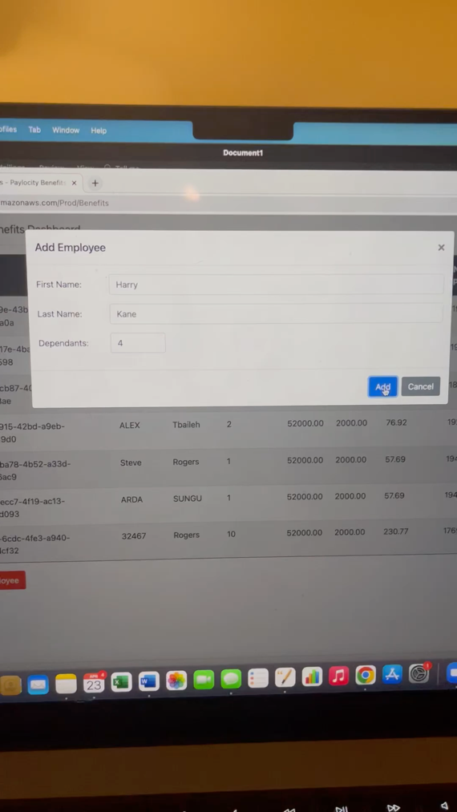

5.While I was adding employees at the same time(crossbrowsing) google chrome and firefox search enginees

System doesn’t let me add the employees.

I tried the same scenario couple of time and result was the same.

I attached a video about it.

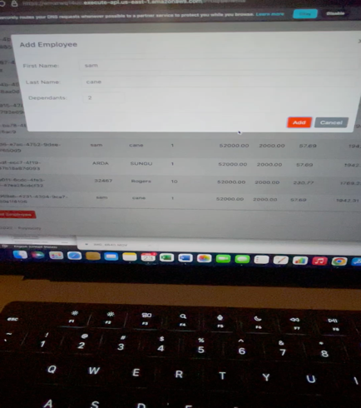

6.I duplicate sam cane Employee Information

Expected result should be an error or text says that duplicate employee

Actual result was Employee created second time(duplicated)

I tried the same scenario couple of time and result was the same.

I attached picture about it.

7.I duplicate SAM CANE Employee Information with capitalize letter

Expected result should be an error or text says that duplicate employee

Actual result was Employee created second time(duplicated)

I tried the same scenario couple of time and result was the same.

I attached picture about it.

8.After a while working on the webpage when I reloaded web page

Expected result should be all the information about employees will be visible

Actual result is not visible.

I tried the same scenario couple of time and result was the same.

I attached picture about it.

